Process flow for using **Microsoft Remote Help** with an **unmanaged device**, including prerequisites, configuration steps, and session workflow:

**Prerequisites**156

**Enable Remote Help for Unenrolled Devices**

Navigate to **Microsoft Intune Admin Center > Tenant Administration > Remote Help > Settings**.

Set **Enable Remote Help** to **Enabled** and toggle **Allow Remote Help to unenrolled devices** to **Enabled**.

*Note*: By default, this setting is disabled and must be explicitly turned on for unmanaged devices.

**Licensing**

Ensure both the **helper** (IT support) and **sharer** (end-user) have valid **Remote Help add-on licenses** or **Intune Suite licenses**.

Assign licenses via the **Microsoft 365 Admin Center** or group-based licensing.

**Install the Remote Help App**

For **unmanaged devices**, the sharer must manually download and install the Remote Help app from [aka.ms/downloadremotehelp](https://aka.ms/downloadremotehelp).

The helper can use either the **desktop app** or the **web app** (limited to view-only mode).

**Configuration Steps**136

**Configure Role-Based Access Control (RBAC)**

Assign the **Help Desk Operator** role (built-in) or create a custom role in **Intune > Tenant Administration > Roles**.

Ensure permissions include:

**View Screen**

**Take Full Control** (if needed)

**Elevation** (to interact with UAC prompts).

*Note*: Unattended access (no user interaction) is **not supported for Windows unmanaged devices** 9.

**Network Requirements**

Ensure the unmanaged device can access:

*.support.services.microsoft.com (primary endpoint).

*.login.microsoftonline.com (Azure AD authentication).

Port **443** (HTTPS) for encrypted RDP traffic over TLS 1.2.

**Process Flow for a Remote Help Session**358

**Initiate the Session**

**Helper Action**:

Open the Remote Help app or web app (via [aka.ms/rhh](https://aka.ms/rhh)).

Generate a **security code** (8 characters for the web app, 6 characters for the desktop app).

**Sharer Action**:

Open the Remote Help app on the unmanaged device and navigate to [aka.ms/rh](https://aka.ms/rh).

Enter the security code provided by the helper.

**Authentication and Compliance Check**

Both parties sign in with **Microsoft Entra ID** (organizational accounts).

The helper receives a **non-compliance warning** if the device violates policies (e.g., outdated OS). This does not block the session but serves as a risk alert 16.

**Session Modes**

**View Screen**: Helper can only observe the sharer’s screen.

**Full Control**: Requires explicit approval from the sharer. The helper can interact with the device (e.g., troubleshoot settings).

**Elevation**: If administrative actions are needed, the helper can input credentials via UAC prompts (requires RBAC permissions).

**Session Tools**

**Laser Pointer/Pen**: Highlight areas on the screen.

**Chat**: Communicate via text (can be disabled in tenant settings).

**Task Manager**: Helper can terminate processes or monitor performance 12.

**Post-Session Actions**112

**Session Logging and Monitoring**

Session details (start/end time, participants) are logged in **Intune > Tenant Administration > Remote Help > Monitor**.

For unmanaged devices, auditing is limited (e.g., no user affinity data for Android devices).

Logs are retained for **30 days** on Microsoft servers.

**Key Limitations**19

**Cross-Tenant Support**: Sessions can’t be established between different tenants.

**Platform Restrictions**: Linux is unsupported (though the web app may work unofficially).

**Unattended Access**: Only available for **Android Enterprise dedicated devices**, not Windows.

For further details, refer to the [Remote Help documentation](https://learn.microsoft.com/en-us/mem/intune/fundamentals/remote-help) or explore the [web app workflow](https://petervanderwoude.nl/post/getting-started-with-the-remote-help-web-app/).

# **Getting started with the Remote Help web app**

June 10, 2024 by [Peter van der Woude](https://petervanderwoude.nl/post/author/pvanderwoude/)

This week is all about the Remote Help web app. Remote Help on itself is nothing new, but it does have an often overlooked feature that can be useful in multiple occasions. That feature is the Remote Help web app. The Remote Help web app can be used to help users on managed and unmanaged devices, without installing the Remote Help app, and in some scenarios even on Linux devices. The former might sound a little bit weird, but due to the nature of the web app, it does technically work in some scenarios to provide support on Linux. Together that makes the Remote Help web app an interesting feature to be familiar with. It is good to know that the web app only supports viewing the shared screen. Besides that, it also good to be familiar with the growing feature set of Remote Help. Remote Help now already provides support for Windows, Android (dedicated devices), and MacOS. This post will focus on the configurations that are specific to fully utilizing the Remote Help web app. This post will end with experiencing the Remote Help web app.

**Note**: Keep in mind that, even though it might work, Linux isn’t officially supported by Remote Help.

## **Enabling Remote Help in the tenant**

Before using the Remote Help web app, on any platform, Remote Help must be enabled for the tenant. After it’s enabled for the tenant, it can be used for providing remote assistance to the different platforms. Especially for providing support to unmanaged devices, there is a specific configuration to keep in mind. That setting is related to unenrolled devices. The following two steps walk through the process of enabling Remote Help for managed and unmanaged devices.

1. Open the [Microsoft Intune admin center](https://intune.microsoft.com/) portal and navigate to **Tenant admin** > **Connectors and tokens** > **Remote Help**
2. On the **Connectors and tokens | Remote Help** page,  as shown below in Figure 1, click **Settings** > **Configure** with the following settings and click **Save**

* **Enable remote help**: Select **Enabled** to enable the Remote Help functionality within the tenant
* **Allow remote help to unenrolled devices**: Select **Allowed** to also allow Remote Help on unmanaged devices
* **Disable Chat**: Select **No** to leave the chat functionality enabled

[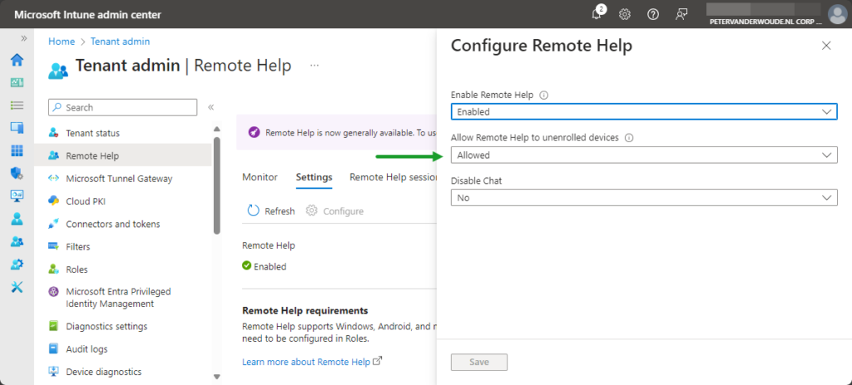](https://petervanderwoude.nl/wordpress/wp-content/uploads/RHWA-ConfigurationSettings.png)Figure 1: Overview of the configuration settings of Remote Help

After enabling Remote Help in the tenant, it’s important to align Conditional Access with the scenario that is going to be used. In this case, that means that Conditional Access is aligned with the usage of the Remote Help web app. And not just using the Remote Help web app, but also the scenarios that must be supported. So, if a user is allowed to use the Remote Help web app on unmanaged devices that must also reflect in Conditional Access. In that scenario don’t require a managed for using Remote Help. That will make the Remote Help web app unavailable on unmanaged devices. For more details around using Conditional Access with Remote Help, please refer to this earlier post about [using Conditional Access for Remote Help](https://petervanderwoude.nl/post/using-conditional-access-for-remote-help/).

## **Using Remote Help web app**

The usage of the Remote Help web app is pretty straight forward and comparable to using the Remote Help apps. Main differentiator is that there is no app required and that it only provides view permissions to the helper. There are many different scenarios in which the Remote Help web app can be useful. The most common scenario is when their is no client app installed. Both, helper and sharer have their own URL for setting up the session. Those are the following URLs:

* **Helper**: <https://aka.ms/rhh> (short link for: <https://remotehelp.microsoft.com/helper>)
* **Sharer**: <https://aka.ms/rh> (short link for: <https://remotehelp.microsoft.com/sharer>)

These URLs are usable on Windows, on MacOS, and in some case on Linux devices. Besides that, the Remote Help web app also generates different security codes compared to the Remote Help client app that is available on the different platforms. When using the Remote Help web app a security code of eight characters is used. The helper shares that security code with the sharer, and after starting and allowing the remote connection, the connection will actually be started (as shown below in Figure 2).

Good to know is that there also warnings when the device that the helper is connecting to is either unmanaged or noncompliant. Both important and good to know, before the helper is actually connecting to the device of the sharer.

[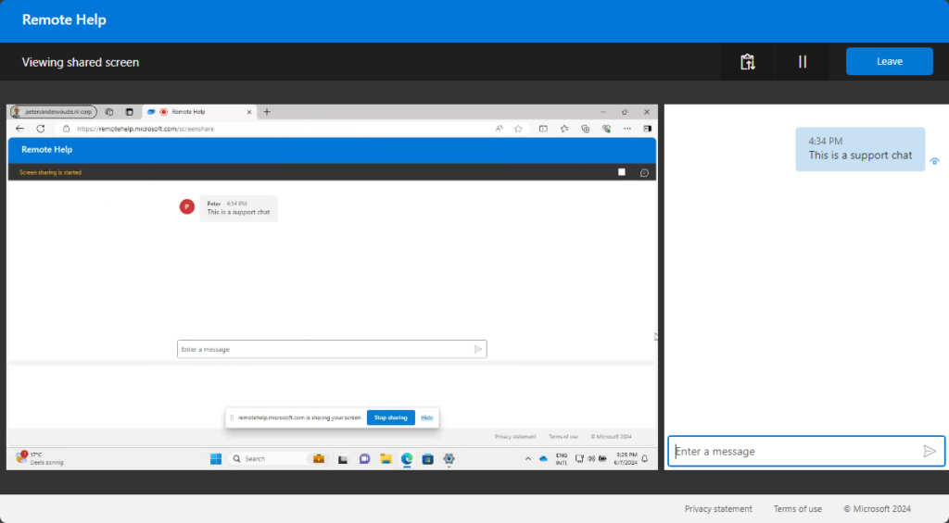](https://petervanderwoude.nl/wordpress/wp-content/uploads/RHWA-UserExperience.png)Figure 2: Overview of the user experience with the Remote Help web app

**Note**: During testing, nearly all Linux distributions, used by sharers, would show the helper an RBAC message.

## **More information**

For more information about Remote Help and the Remote Help web app, refer to the following docs.

* [Use Remote Help to assist users authenticated by your organization. | Microsoft Learn](https://learn.microsoft.com/en-us/mem/intune/fundamentals/remote-help?WT.mc_id=EM-MVP-5001447)
* [Using Remote Help Web App. – Microsoft Intune | Microsoft Learn](https://learn.microsoft.com/en-us/mem/intune/fundamentals/remote-help-webapp?WT.mc_id=EM-MVP-5001447)

<https://techcommunity.microsoft.com/blog/coreinfrastructureandsecurityblog/enabling-remote-help-and-supporting-users-with-intune/3754586>

# **Getting started with the Remote Help web app**

June 10, 2024 by [Peter van der Woude](https://petervanderwoude.nl/post/author/pvanderwoude/)

This week is all about the Remote Help web app. Remote Help on itself is nothing new, but it does have an often overlooked feature that can be useful in multiple occasions. That feature is the Remote Help web app. The Remote Help web app can be used to help users on managed and unmanaged devices, without installing the Remote Help app, and in some scenarios even on Linux devices. The former might sound a little bit weird, but due to the nature of the web app, it does technically work in some scenarios to provide support on Linux. Together that makes the Remote Help web app an interesting feature to be familiar with. It is good to know that the web app only supports viewing the shared screen. Besides that, it also good to be familiar with the growing feature set of Remote Help. Remote Help now already provides support for Windows, Android (dedicated devices), and MacOS. This post will focus on the configurations that are specific to fully utilizing the Remote Help web app. This post will end with experiencing the Remote Help web app.

**Note**: Keep in mind that, even though it might work, Linux isn’t officially supported by Remote Help.

## **Enabling Remote Help in the tenant**

Before using the Remote Help web app, on any platform, Remote Help must be enabled for the tenant. After it’s enabled for the tenant, it can be used for providing remote assistance to the different platforms. Especially for providing support to unmanaged devices, there is a specific configuration to keep in mind. That setting is related to unenrolled devices. The following two steps walk through the process of enabling Remote Help for managed and unmanaged devices.

1. Open the [Microsoft Intune admin center](https://intune.microsoft.com/) portal and navigate to **Tenant admin** > **Connectors and tokens** > **Remote Help**
2. On the **Connectors and tokens | Remote Help** page,  as shown below in Figure 1, click **Settings** > **Configure** with the following settings and click **Save**

* **Enable remote help**: Select **Enabled** to enable the Remote Help functionality within the tenant
* **Allow remote help to unenrolled devices**: Select **Allowed** to also allow Remote Help on unmanaged devices
* **Disable Chat**: Select **No** to leave the chat functionality enabled

[](https://petervanderwoude.nl/wordpress/wp-content/uploads/RHWA-ConfigurationSettings.png)Figure 1: Overview of the configuration settings of Remote Help

After enabling Remote Help in the tenant, it’s important to align Conditional Access with the scenario that is going to be used. In this case, that means that Conditional Access is aligned with the usage of the Remote Help web app. And not just using the Remote Help web app, but also the scenarios that must be supported. So, if a user is allowed to use the Remote Help web app on unmanaged devices that must also reflect in Conditional Access. In that scenario don’t require a managed for using Remote Help. That will make the Remote Help web app unavailable on unmanaged devices. For more details around using Conditional Access with Remote Help, please refer to this earlier post about [using Conditional Access for Remote Help](https://petervanderwoude.nl/post/using-conditional-access-for-remote-help/).

## **Using Remote Help web app**

The usage of the Remote Help web app is pretty straight forward and comparable to using the Remote Help apps. Main differentiator is that there is no app required and that it only provides view permissions to the helper. There are many different scenarios in which the Remote Help web app can be useful. The most common scenario is when their is no client app installed. Both, helper and sharer have their own URL for setting up the session. Those are the following URLs:

* **Helper**: <https://aka.ms/rhh> (short link for: <https://remotehelp.microsoft.com/helper>)
* **Sharer**: <https://aka.ms/rh> (short link for: <https://remotehelp.microsoft.com/sharer>)

These URLs are usable on Windows, on MacOS, and in some case on Linux devices. Besides that, the Remote Help web app also generates different security codes compared to the Remote Help client app that is available on the different platforms. When using the Remote Help web app a security code of eight characters is used. The helper shares that security code with the sharer, and after starting and allowing the remote connection, the connection will actually be started (as shown below in Figure 2).

Good to know is that there also warnings when the device that the helper is connecting to is either unmanaged or noncompliant. Both important and good to know, before the helper is actually connecting to the device of the sharer.

[](https://petervanderwoude.nl/wordpress/wp-content/uploads/RHWA-UserExperience.png)Figure 2: Overview of the user experience with the Remote Help web app

**Note**: During testing, nearly all Linux distributions, used by sharers, would show the helper an RBAC message.

## **More information**

For more information about Remote Help and the Remote Help web app, refer to the following docs.

* [Use Remote Help to assist users authenticated by your organization. | Microsoft Learn](https://learn.microsoft.com/en-us/mem/intune/fundamentals/remote-help?WT.mc_id=EM-MVP-5001447)
* [Using Remote Help Web App. – Microsoft Intune | Microsoft Learn](https://learn.microsoft.com/en-us/mem/intune/fundamentals/remote-help-webapp?WT.mc_id=EM-MVP-5001447)